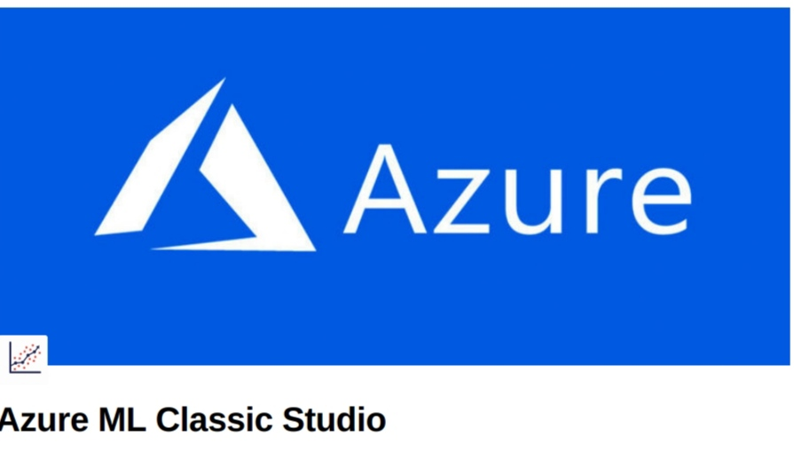
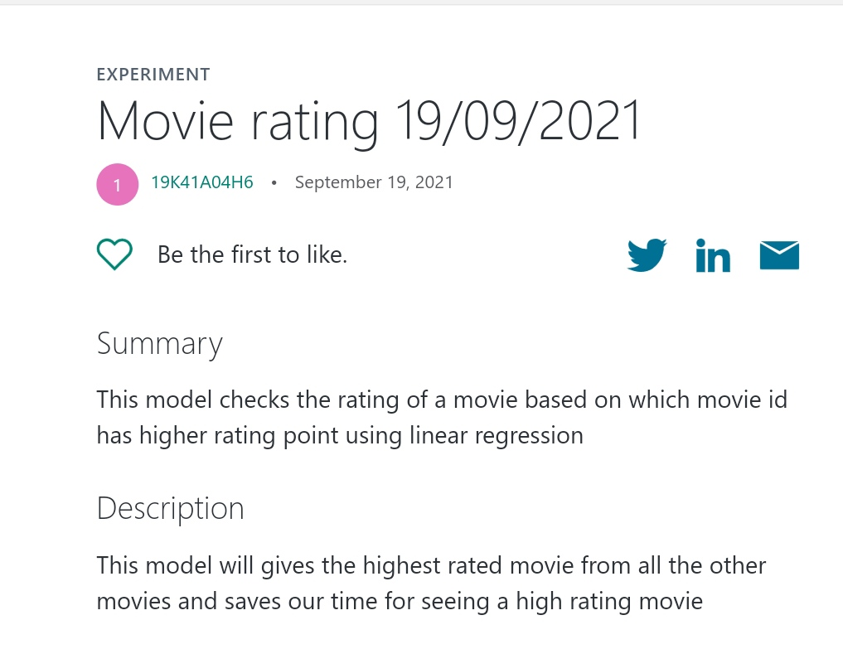
Gallery link:
https://gallery.azure.ai/Experiment/Movie-rating-19-09-2021#

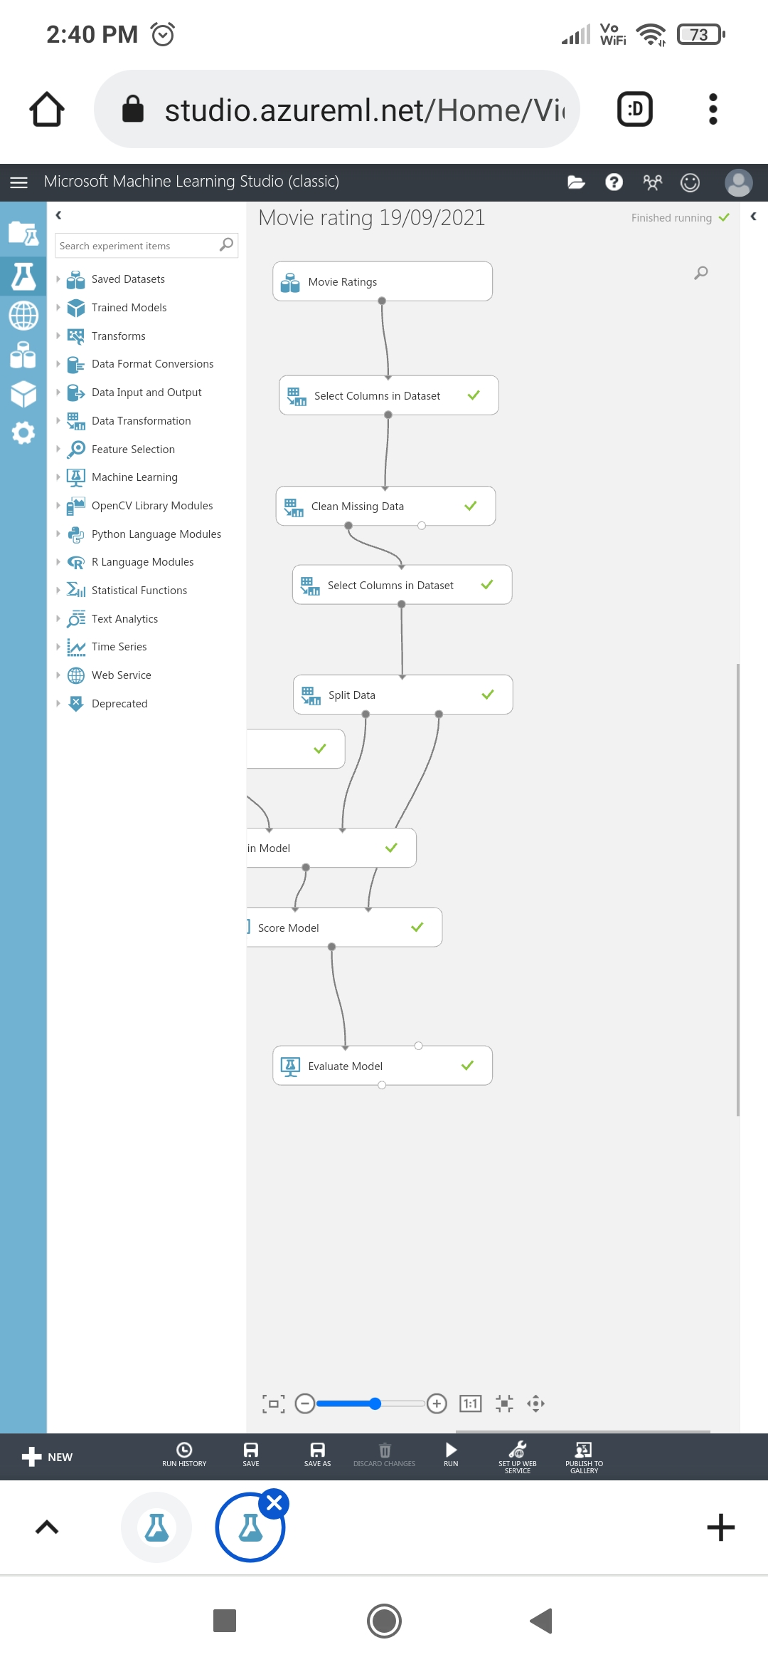
Workflow

Import Data:
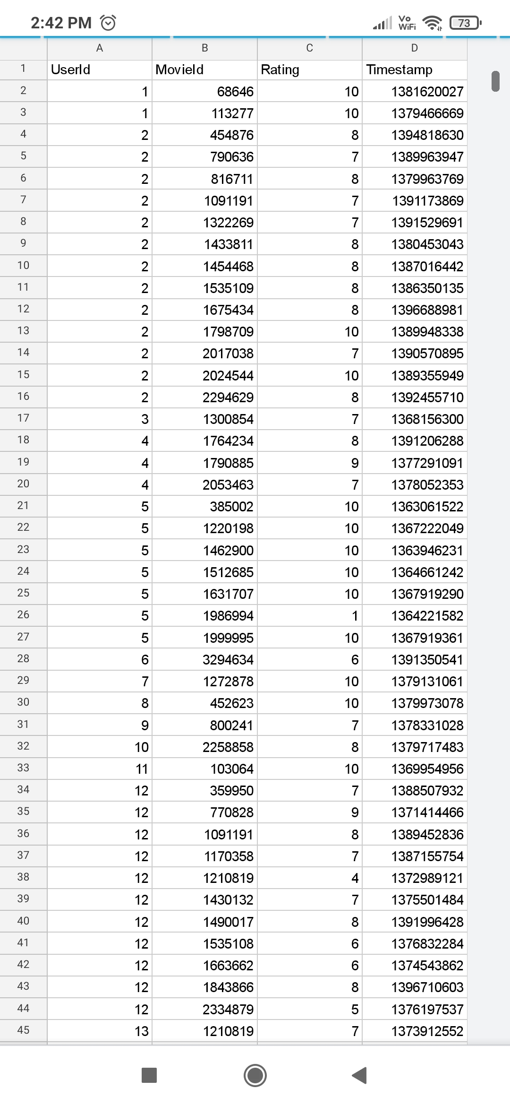
importing the RAW dataset which is in CSV format.
the dataset is pre-available in the Azure ML Classic Studio.

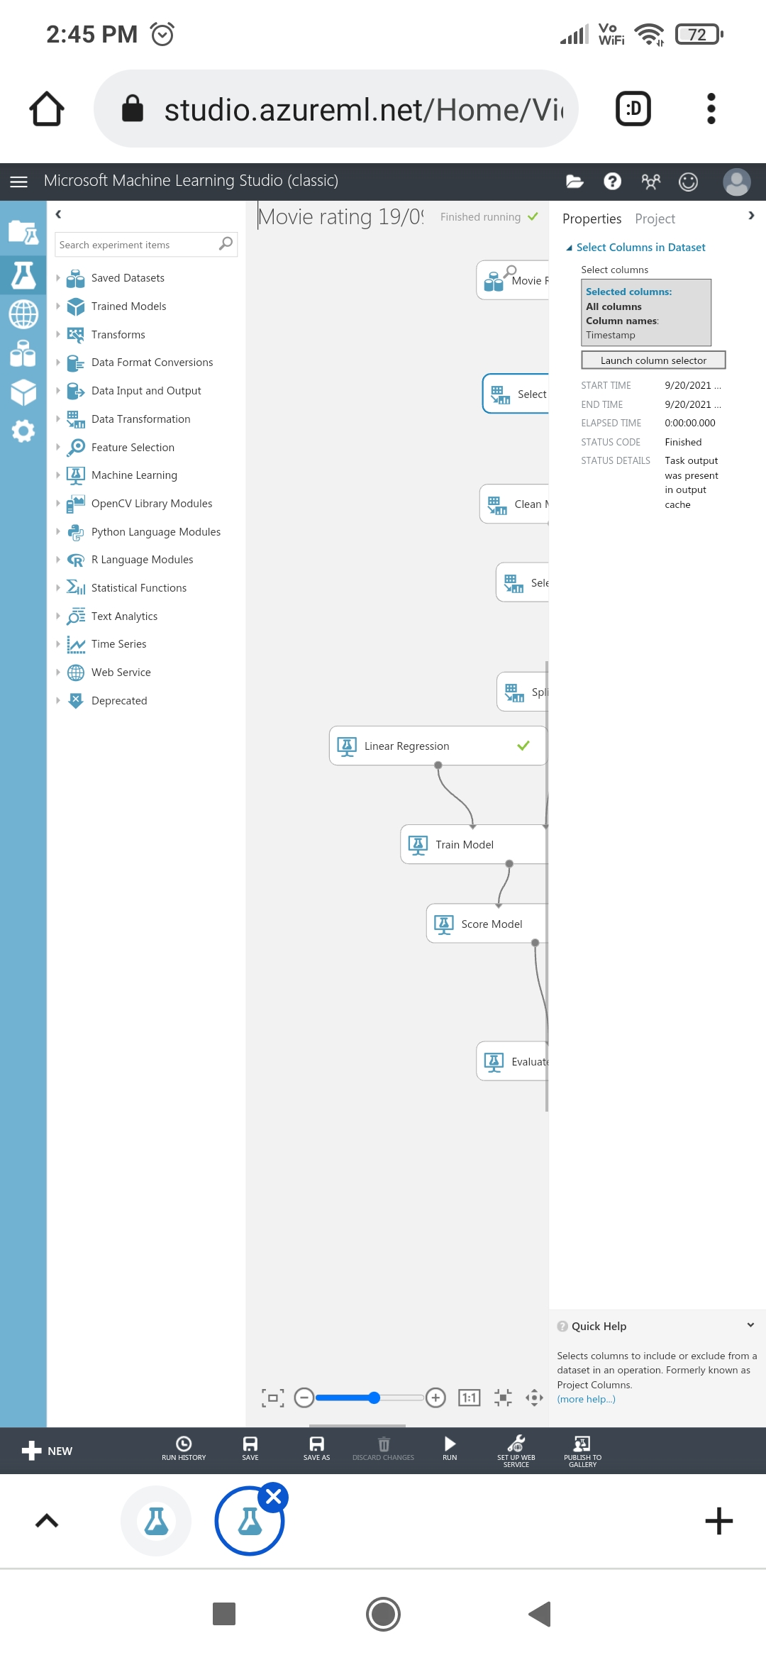

Explore Data
this basically includes data visualization to search for any missing values in the Dataset.
if any missing values are found, then they needs to be cleaned.
selecting the required columns and clean the data using the Clean Missing Value module (Just Drag n' Drop )

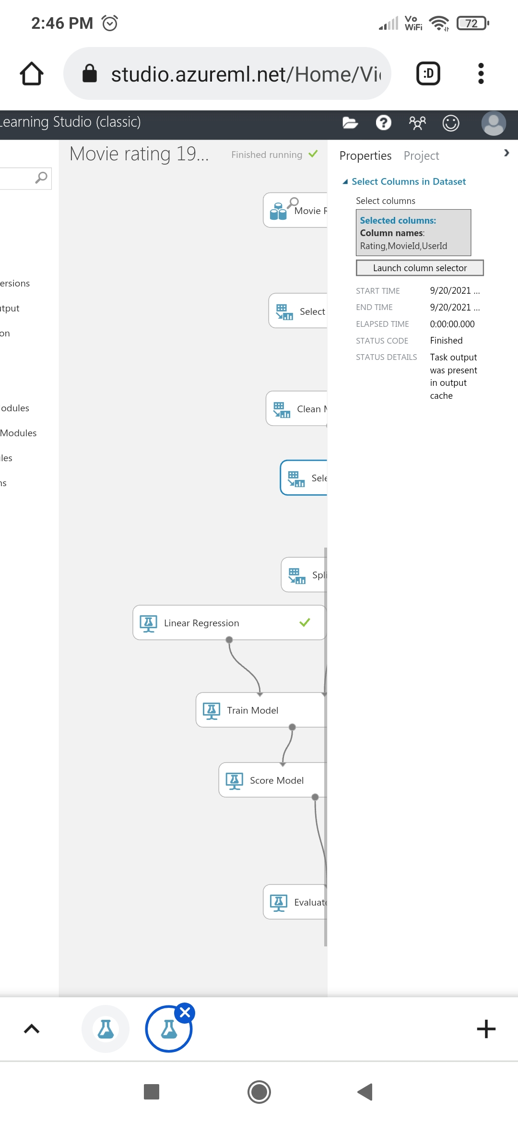

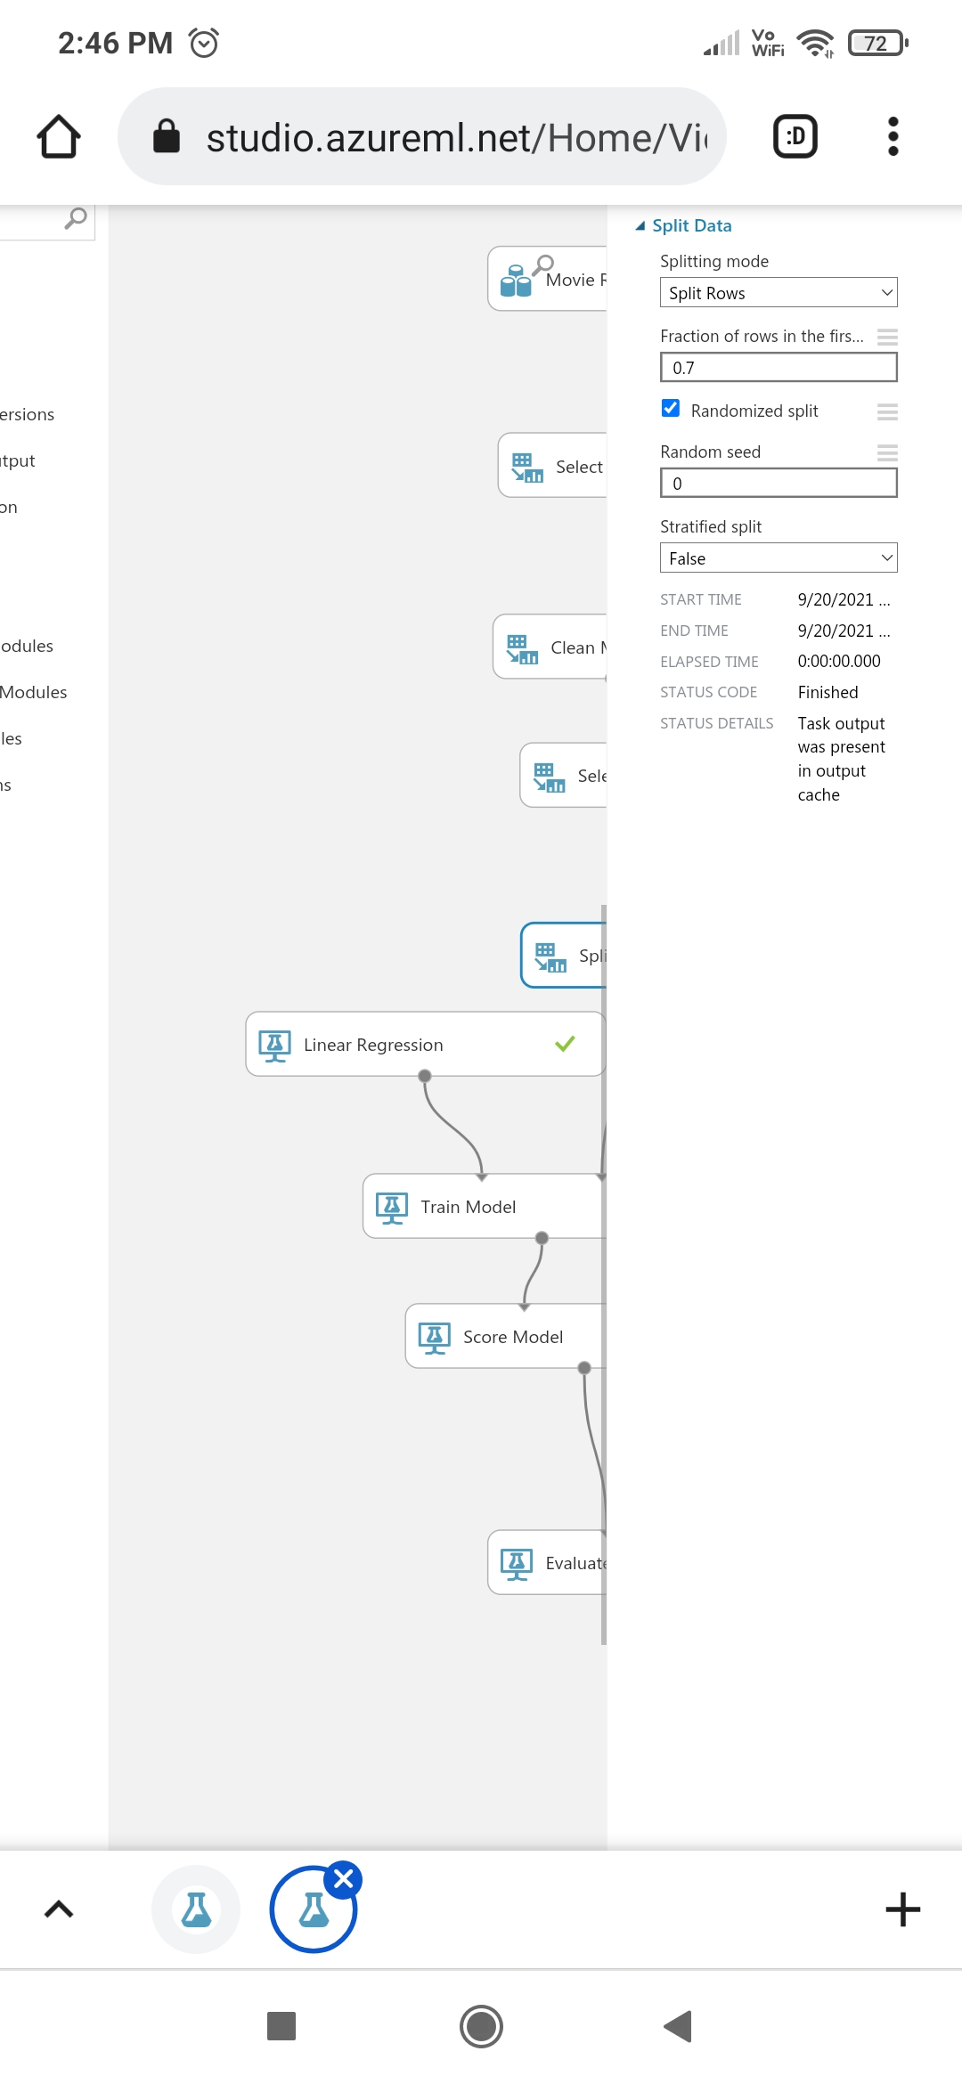

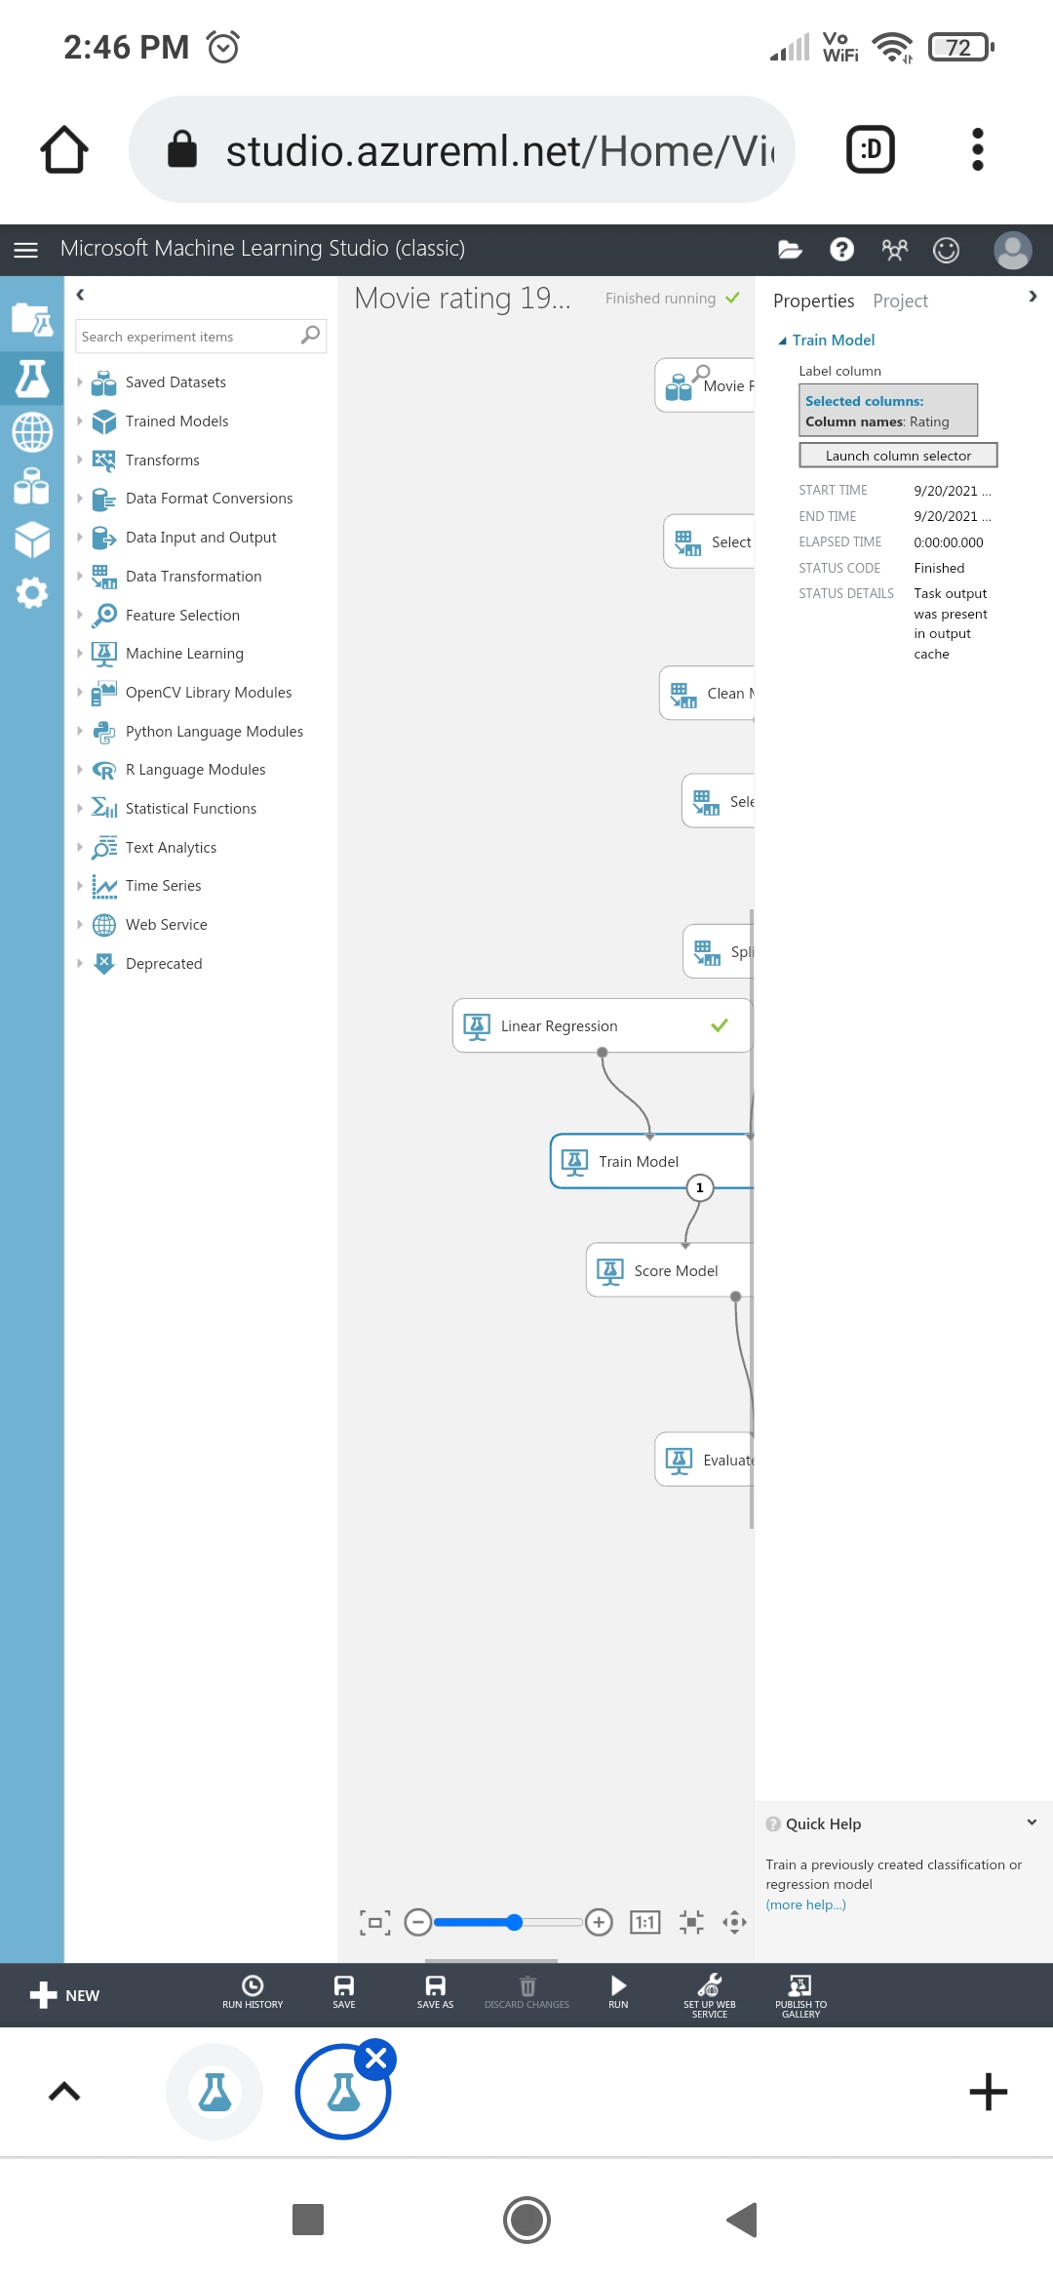

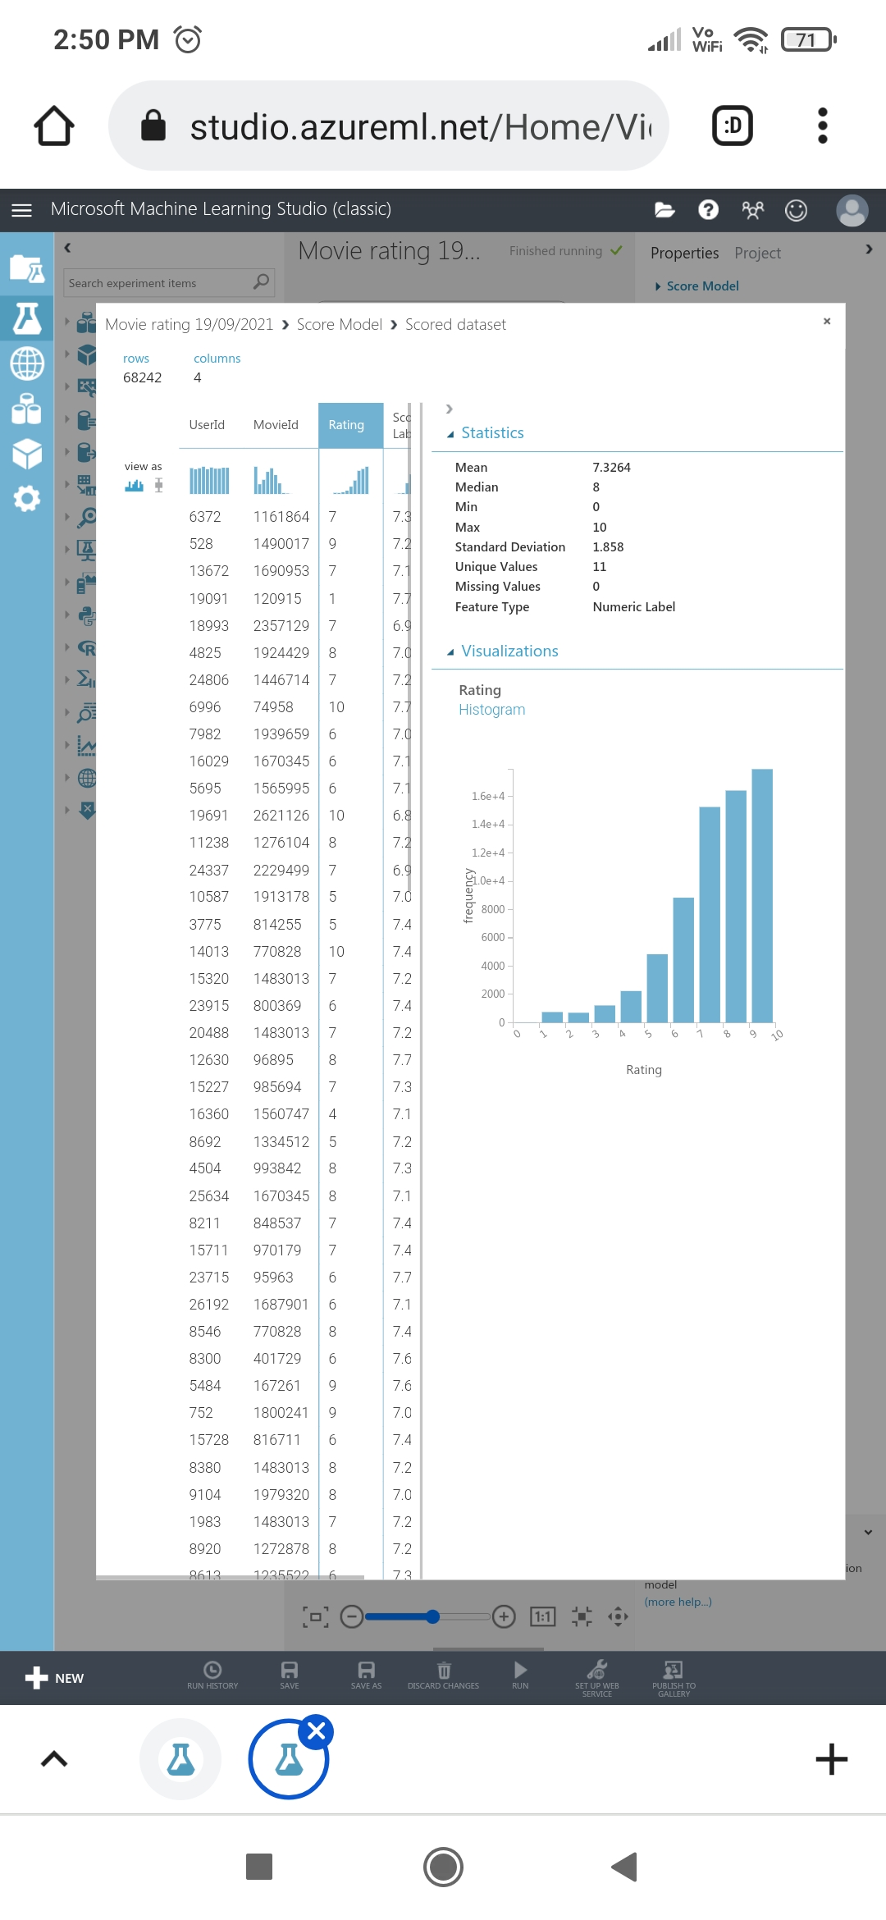
Score Model and Evaluate Model:
After the model is trained, we can use the Score Model and Evaluate Model modules to generate predicted results and evaluate the models

Evaluation Results




